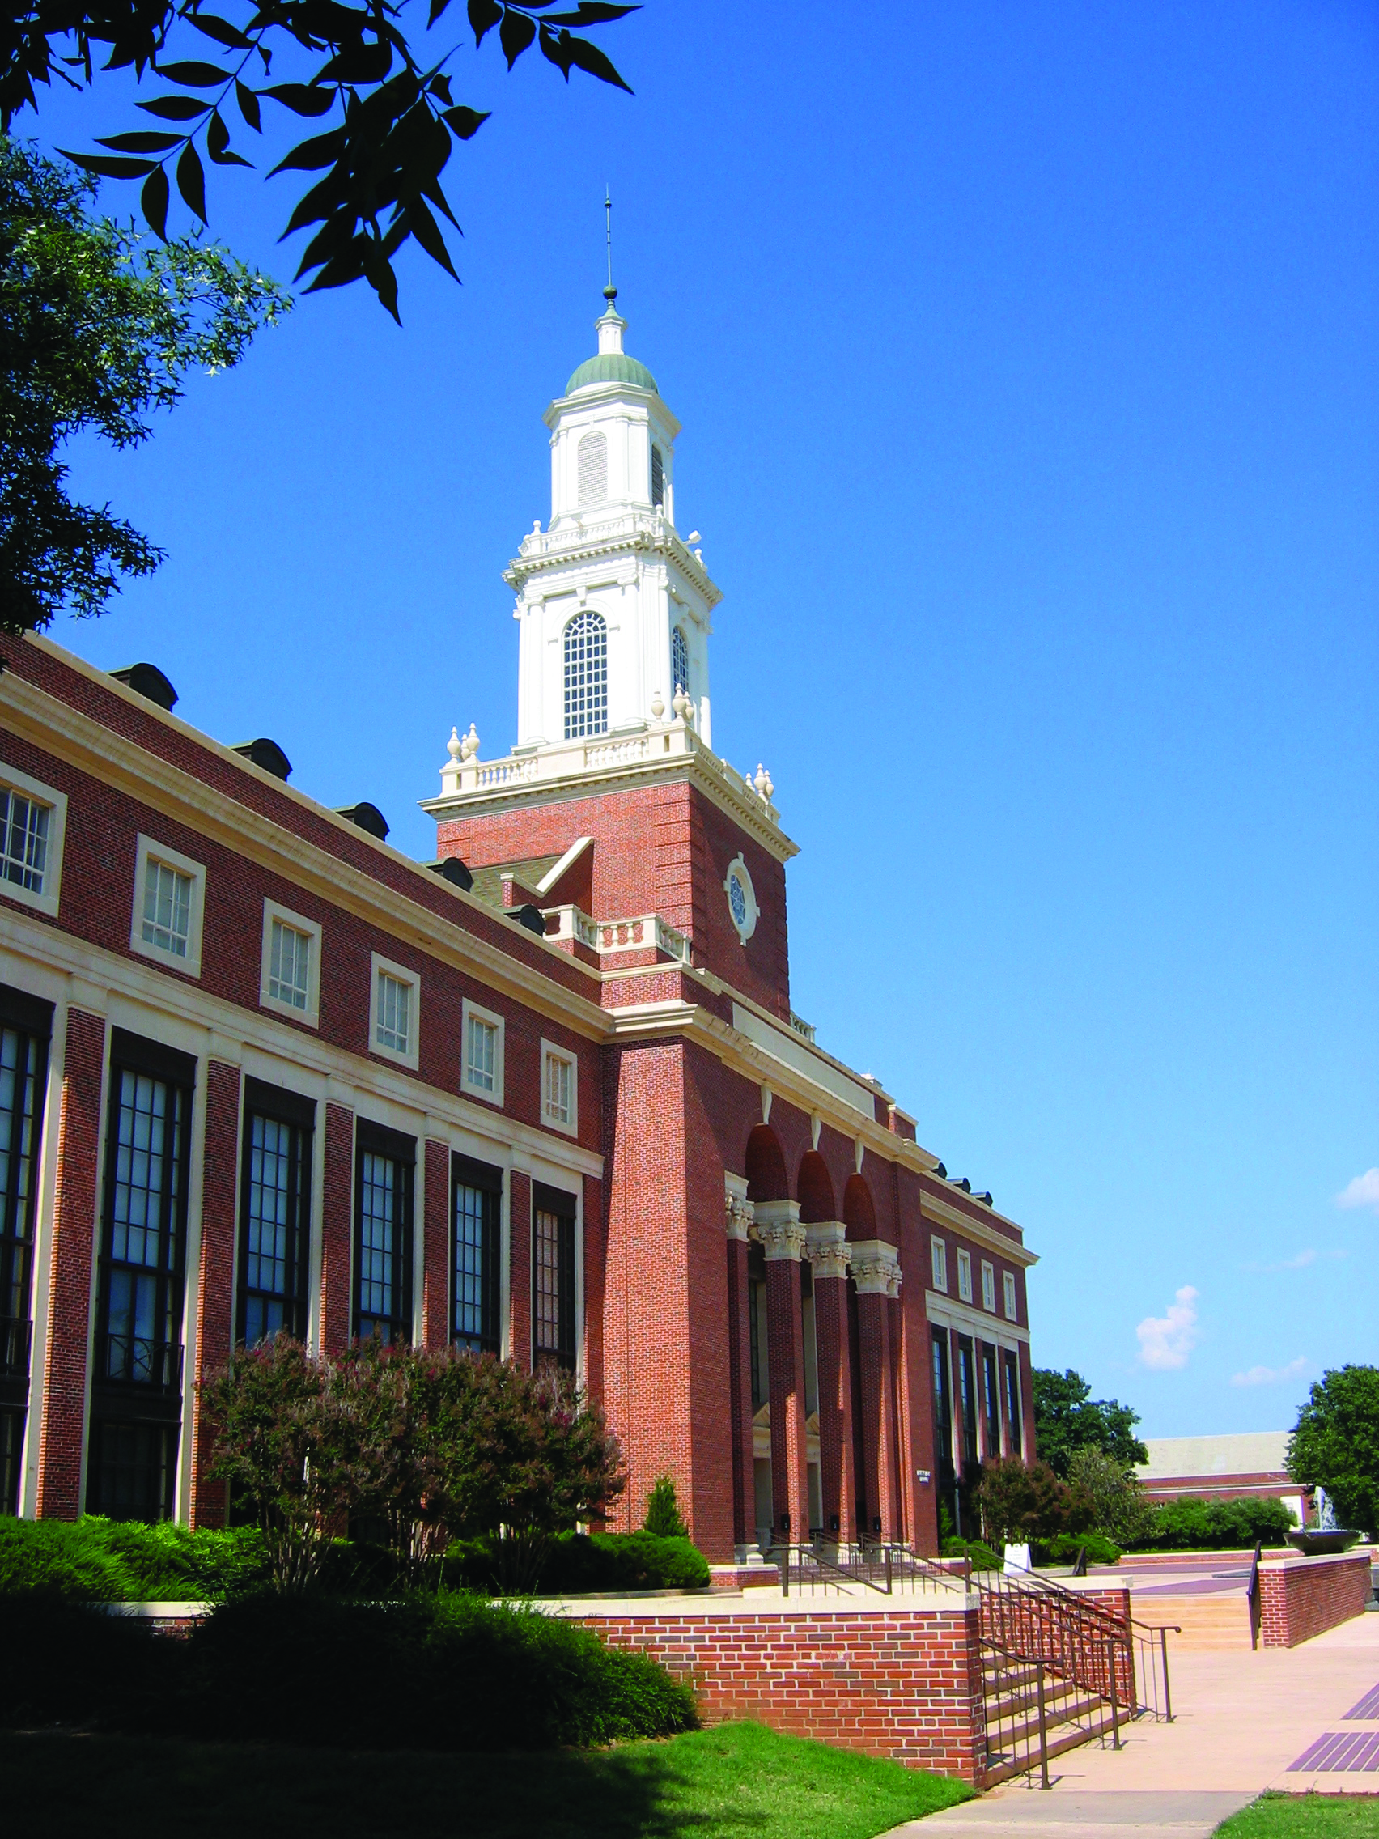
Oklahoma State University
Design Guidelines

Overview
The Oklahoma State University Stillwater Campus has long been known for its elegance, atmosphere and architectural unity. Its buildings and outdoor spaces are an integral part of OSU’s historic heritage and its ongoing purpose and mission. Alumni, faculty, staff, students and visitors all appreciate this architectural cohesion that is such a feature of the campus. While the exterior aesthetic of the Stillwater campus portrays a sense of permanence and longevity, the interior spaces of the campus should portray a current, yet timeless sense of design aesthetic which reflects the university’s value of the activities that take place inside these spaces. These spaces should be comfortable, durable and support the most current research occurring alongside a dynamic teaching paradigm. The goal of the Design Guidelines is to assist in the preservation of the character and integrity of the OSU-Stillwater campus.
Edmon Low Library
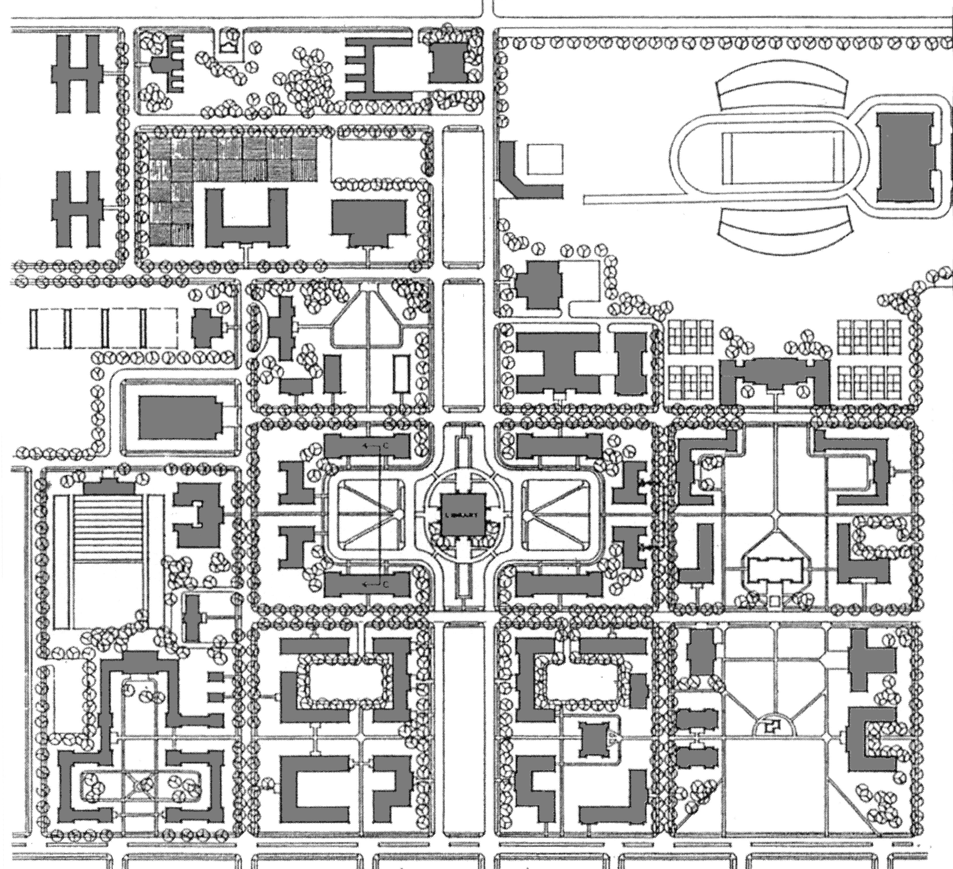
The most significant influence on the campus has been and remains the Bennett Plan of the late 1920s. It established what is commonly known as “Modified Georgian” as OSU’s architectural style and organized the campus layout via a grid of major and minor axes and designated a series of open quadrangles around which buildings are located. The consistency in style and layout called for by the Bennett Plan are essential to the look and feel of the campus and are central to the Campus Master Plan and these design guidelines.
The OSU office of Long Range Facilities Planning (LRFP), which manages all academic construction projects with a cost of $4 million or more on the OSU Stillwater and Tulsa campuses, is charged with oversight of the Campus Master Plan and reviews the design of all buildings and any work not internal to a building such as a change to a building façade, hard and soft landscaping, above ground utilities, sidewalks, etc. These Design Guidelines are an appendix to the Campus Master Plan and will be administered by LRFP.
Bennett Plan

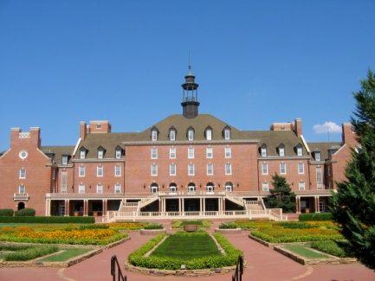
Exterior Design Guidelines
The following Guidelines begin with broader issues relating to the campus as a whole and continue to the more specific issues relating to the individual building.
Campus Plan Philosophy – Elegance, unity and restraint are hallmarks of the campus design philosophy as is adherence to the principles of the Bennett Plan. Any building design that attempts to stand apart from its campus environment is inappropriate. Even the most prominent buildings on campus exhibit a consistency and harmony with the campus as a whole. At OSU, we don’t do “Wow!”
Student Union
Hierarchy – Buildings on campus can be classified as either foreground buildings or background buildings.
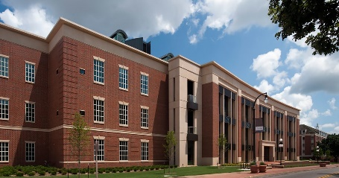
Foreground buildings serve the university as a whole and are the landmark structures of the campus. They tend to be larger and iconic with features, proportions, and details that allow them to act as focal points. Towers, cupolas or other highly prominent features are reserved for foreground buildings. The Edmon Low Library, the Student Union, and the Henry Bellmon Research Center are examples of foreground buildings.
Background buildings are designed to enhance the harmony of the campus landscape and blend in with the campus fabric. While they should be of high quality in their design, aesthetics, and construction, they do not draw undue attention to themselves and avoid showiness or ostentation. Background buildings should not be taller at their highest point (excluding chimneys) than the roof peak of the Edmon Low Library. Most buildings on campus, including those that house the colleges, are background buildings.
Henry Bellmon Research Center
|
Inter-building Relationships – To preserve the sense of unity on campus, it is essential that designers carefully consider how their design will relate to existing and planned adjacent structures. Spaces that are defined between buildings should be designed with the same attention to form and function that interior spaces are.
Common service access areas – Every attempt should be made to group service access points between adjacent buildings to minimize their impact in terms of circulation, area and aesthetics. Designing service areas so as to be aesthetically pleasing is preferable to hiding or disguising an eyesore.
Setback Lines – While there are no specific requirements for setbacks from streets or sidewalks designers should observe typical and existing setbacks. In the event that no precedent exists, designers will consult with LRFP to establish acceptable conditions.
Sustainability – OSU’s architectural style has a green heritage; it is derived from styles that were the most sustainable of their times. The University is committed to build on the tradition of sustainability in every building project it undertakes. Using resources wisely is not only better for the environment; it also gets the most out of budget, research and contribution dollars and is an important part of educating a responsible student body. Every design process for projects on campus must include a careful and complete consideration of the best sustainable strategies and applications.
Red brick, white trim, slate roofs, and dormer windows are some of the characteristics of Georgian architecture. We have red brick, white trim and the brown-green roofs. Some of our roofs are flat, and couldn’t be otherwise. Some are pitched. Architectural style? Just call it pseudo-collegiate-Georgian-Oklahoma-Bennett-Wilber-et al 1930-40-50-60”.
-Phil Wilber, former Campus Architect on OSU’s architectural style
Accessibility – All new construction is to be designed and constructed as compliant with both building code accessibility requirements and the Federal ADA law. The responsibility to meet this requirement resides with licensed design professionals and the construction professionals. Accessibility in existing buildings is accomplished during renovations.

The OSU Architectural Style
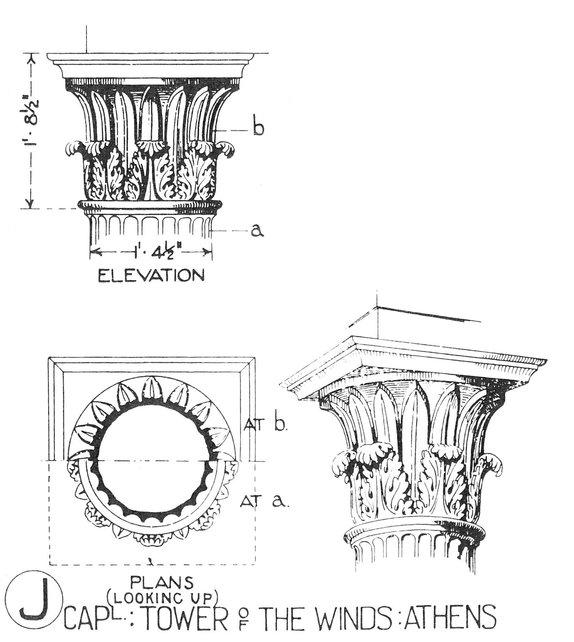
As previously mentioned, OSU’s architectural style is typically referred to as “Modified-Georgian” which is based on the classical styles of the late 17th and 18th centuries in Britain and North America. Social Sciences and Humanities, Willard Hall, Stout Hall, Engineering South and other buildings of the 1930s and 1940s exemplify this style. Later buildings, such as Engineering North, Physical Sciences or Agriculture Hall, attempted a Modernist interpretation of the OSU style that, while definitely not Modified-Georgian, does not appear out of place. Buildings of the late 20th century however, were either radically different or inappropriate or attempted to use Georgian precedents but without sound knowledge of the style resulting in interpretations of the style that are banal and/or illiterate. Some particular characteristics of the OSU architectural style are discussed below.
Proportions – Buildings tend to be horizontal in nature, wider than they are deep, and typically three to four stories in height. When a fourth floor is included, it is generally in the “attic”, under the slope of the roof and naturally lit via dormers. Horizontally, the façade is clearly divided into a base, middle and top.
Symmetry – Symmetry, particularly in elevation, is ideal. Main entrances are located on the longer of the facades and are either one central entrance or dual, symmetric entrances, often embellished with stone detailing.
Architectural Elements – Hip or gable roofs, chimneys, dormers, quoins, OSU Corinthian columns and stone details such as entablatures, cornices, string courses, sills, lintels, keystones are typical of OSU’s architectural style.
|
Materials – The consistent use of exterior materials is critical to maintaining consistency and unity on campus. OSU-blend brick, stone and cast stone accents, white trim, and brown-green or gray-green roofing are preferred exterior materials. More flexibility is allowed when choosing materials for interiors or courtyards.
OSU Corinthian (Illustration from Sir Bannister Fletcher’s “A History of Architecture.”

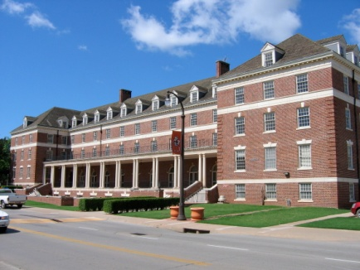
Windows – Windows are typically double-hung with muntins, and white or off-white in color. They are evenly and symmetrically spaced within the façade but may change height or width by floor or façade element. Curtain walls, corner-wrapping windows, and glass facades are generally not appropriate but may be allowed following appropriate consultation with LRFP.
Fakery – The application of architectural elements purely for appearance that are obviously fake, such as false dormers or chimneys, is to be avoided.
Subtlety – Classical architecture can appear to be dull, constrained by its use of symmetry, proportion and regularity but detailed study of good examples reveals design subtlety, variety, meaning, and even humor. This is why it has survived for many centuries and is as valid in the 21st century as it was for ancient civilizations and in the Renaissance.
Social Sciences and Humanities

Interior Design Guidelines
Color Palette – OSU’s interior aesthetic should reinforce the Cowboy brand, of being warm and welcoming, not afraid of hard work. Interior color palette should give a nod to our school colors without being harsh. Shades of gray and cream with accents of orange. (There is such a thing as too much orange)
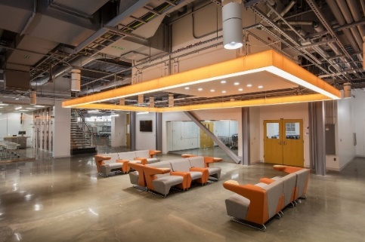
OSU Stillwater has long used a proprietary wall paint color known as OSU Bone throughout campus as the field color. That color is a warm creamy tone and can be used as a starting point for an interior color palette.
A light gray paint color has been incorporated in several new construction projects that is a bit more current and provides a nice neutral field color. SW7015 – Repose Gray
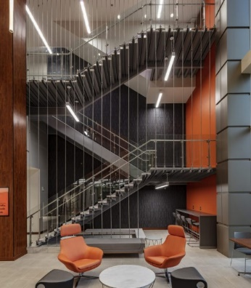
It is often desired to have an accent wall within offices, conference rooms, lobbies, and teaching spaces. Locations and color for accent walls are subject to approval by the University Architect. A medium gray and dark gray have been identified as compatible accent colors with either field color. SW 7643 Pussywillow and SW 7018 Dovetail respectively.
CEAT Endeavor
Three orange paint colors have been identified as accent orange colors that are dependent on other tones in the project palette. Upholstery and carpet chosen within the space may govern which accent color is recommended. SW 6886 – Invigorate; SW 6885 Knockout Orange; SW6884 – Obstinate Orange. The official pantone color of Orange Spot 21 is also an option but can be difficult to coordinate with other interior finishes.
Greenwood School of Music
The Stillwater Campus interior color palettes can be found here: Insert link
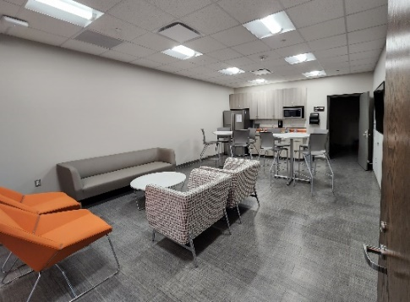
Material Performance – An active university campus sees an incredible amount of traffic throughout its circulation, teaching, and public spaces. As mentioned above under Sustainability, it is a good practice to use dollars wisely to achieve longevity in materiality.
Flooring – Building lobbies and entry points should have durable finishes, typically porcelain tile with integrated walk-off mats. First floor circulation spaces often have tile or resilient flooring while upper floors may have carpet in circulation spaces as well as offices. Areas that encourage food and drink consumption should consider flooring that handles spills. Classrooms and laboratories should have a flooring that is appropriate for activities, bearing in mind cleanability and acoustic performance.
Ray and Linda Booker Flight Center
Walls – gypsum board walls should be finished no higher than a level 3 or 4 unless a wall covering is to placed that recommends a higher level of finish. Wall coverings are not widely used as they are not easy to repair/replace. Corner guards should be considered for all corridors. Wet walls in toilet rooms should have wall tile extending above any wall partitions.
Ceilings – should be considerate of the required acoustic performance for the activity occurring within the space.
Additional recommended performance qualities can be found here: Insert link
Conclusion - One of the many strengths of the OSU-Stillwater campus is the architecture, unified by the Modified-Georgian. To maintain this architectural unity it is important that potential consultants demonstrate an understanding and command of the Georgian style and Classical Architecture and its correct usage in new buildings that additionally meet the needs of the present day.
The purpose of these design guidelines is to assist the OSU Community as they consider a construction project and architectural consultants as they prepare designs.
Long Range Facilities Planning
505 Scott Hall
Stillwater, OK 74078-8059
Tel: 405 744 1062

